Project Design Phase-II
Data Flow Diagram & User Stories

Date | 25 September 2026
Team ID | SWTID-2026-4498
Project Name | AI BlogNest - Generate high-quality blog content using AI.
Maximum Marks | 4 Marks

Data Flow Diagrams:
A Data Flow Diagram (DFD) is a traditional visual representation of the information flows within a system. A neat and clear DFD can depict the right amount of the system requirement graphically. It shows how data enters and leaves the system, what changes the information, and where data is stored.

Example: (Simplified)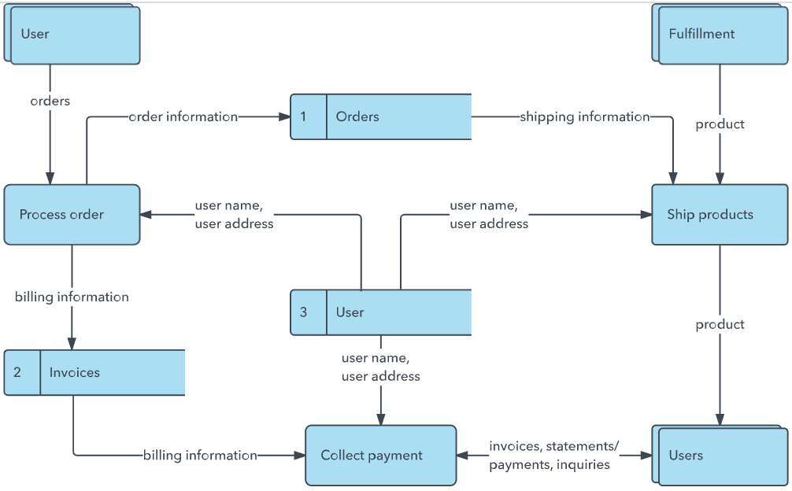
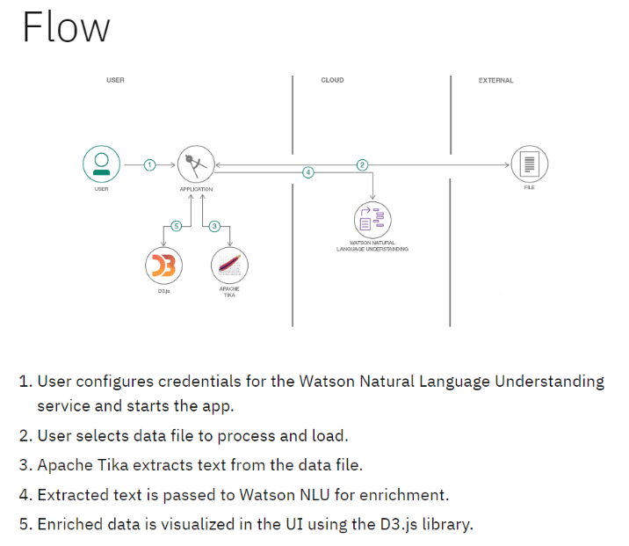

User Stories
Use the below template to list all the user stories for the product.
User Type | Functional Requirement (Epic) | User Story Number | User Story / Task | Acceptance criteria | Priority | Release
Customer (Mobile user) | Registration | USN-1 | As a user, I can register for the application by entering my email, password, and confirming my password. | I can access my account / dashboard | High | Sprint-1
Customer (Web user) | Registration | USN-2 | As a user, I will receive confirmation email once I have registered for the application | I can receive confirmation email & click confirm | High | Sprint-1
Customer (Web user) | Login | USN-3 | As a user, I can register for the application through Facebook | I can register & access the dashboard with Facebook Login | Low | Sprint-2
Customer (Web user) | User Confirmation | USN-4 | As a user, I can register for the application through Gmail | My account is successfully verified. | Medium | Sprint-1
Customer (Web user) | Dashboard | USN-5 | As a user, I can log into the application by entering email & password | I can access blog generation and saved blogs. | High | Sprint-1
Customer (Web user) | AI Blog Generation | USN-6 | As a user, I can enter a topic and generate a blog using AI. | A blog is generated based on the entered topic. | High | Sprint-2
Customer (Web user) | AI Blog Generation | USN-7 | As a user, I can select the length and tone of the blog. | The generated blog follows the selected length and tone. | Medium | Sprint-2
Customer (Web user) | Blog Management | USN-8 | As a user, I can edit the AI-generated blog. | I can modify and update the generated content. | High | Sprint-2
Customer (Web user) | Blog Management | USN-9 | As a user, I can save generated blogs. | The blog is stored and available in my saved blogs. | High | Sprint-2
Customer (Web user) | Blog Management | USN-10 | As a user, I can copy or download my generated blog. | I can copy or download the blog successfully. | Medium | Sprint-2
Administrator | User Management | USN-11 | As an administrator, I can view and manage registered users. | I can view user details and manage accounts. | Medium | Sprint-3
Administrator | Blog Management | USN-12 | As an administrator, I can manage inappropriate or unwanted content. | I can review and remove unwanted content. | Medium | Sprint-3

